**Human Genome Project:**

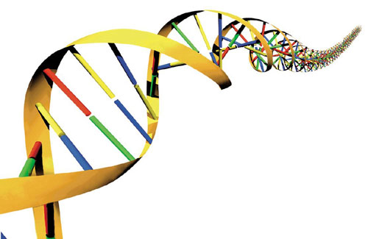

**Vocabulary:**

1. Genome: the ***genome*** is ALL of the DNA inside of a cell.
2. Gene: a ***gene*** is just ONE piece of the DNA inside of a cell.

The word “genome” means the complete set of genes in an organism. So, if you’re talking about the “genome” of an organism, you’re talking about all of its DNA.

The human genome project was an ongoing effort to analyze the human genome. So, basically, it was an attempt to read all of the human DNA like a book to figure out which sequences of DNA coded for which traits (like eye color and hair color and height).

The **goals** of the human genome project were:

1. Identify all the genes in the human genome.
2. Store this information in a database.
3. Use the information to improve science and medicine.

**Biotechnology:**

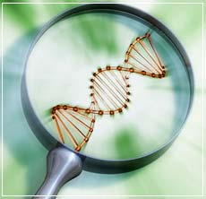

**Vocabulary:**

1. Bio: this means “life” or “living.”
2. Technology: use or knowledge of tools/techniques in an attempt to solve a problem or make a discovery.

“Bio” means life, and “technology” is usually talking about the use of advancements like computers or specialized tools.

So, biotechnology is the manipulation of LIVING things to produce useful outcomes.

To **MANIPULATE** an organism means to CHANGE IT GENETICALLY (to change its DNA).

We often change organism so that they have more favorable characteristics. For example, farmers alter fruit to be larger or sweeter. Also, some farm owners alter cows or pigs to be larger or have more muscle or to grow faster.

**Cloning:**



**Vocabulary:**

1. Clone: exact copy of a living thing.
2. Ethics: question of right and wrong.

A “clone” is an EXACT copy of an organism. So, if my dog dies, I can use his DNA to create an EXACT copy of my old dog.

There are two types of cloning:

1. Therapeutic Cloning: the cloning of cells to use in medicine.

2. Reproductive Cloning: the cloning of the entire organism.

An interesting idea is to use cloning to help endangered species not become extinct by making new, exact copies of the individual s that can be found.

A negative aspect to cloning is that a lot of cloned organisms have health issues like cancers.

There are MANY sides to the issue of cloning! Some people think all cloning is wrong, some think only reproductive cloning is wrong, and others believe that cloning (including human cloning!) is a technology that should continue to be researched.

**Gene Therapy:**



**Vocabulary:**

1. Gene: a ***gene*** is just ONE piece of the DNA inside of a cell.
2. Therapy: this is a procedure that seeks to **help** or **heal**.

“Genes” are sequences of DNA that code for a protein, and “therapy” is a technique used to help or heal.

So, gene therapy is a technique used to give a patient with a faulty (or bad) sequence of DNA the correct sequence of DNA, so they will be healed or helped.

The healthy (correct) gene sequence is inserted using a **virus.**

Gene therapy is in early stages, but it has the chance to cure cancers and diseases of all sorts.

**Stem Cell Research:**



**Vocabulary:**

1. Adult Stem cell: a type of cell that can became a FEW other types of cells
2. Embryonic Stem cell: a type of cell that can become ANY other cell type

If we say a cell “stems” from another cell, we are saying that the cell CAME from (or stemmed from) the other cell.

In our bodies, we have lots and lots of different cells. But, don’t forget that we all started as just one cell. That cell divided into more and more cells. So, we started as a few unspecific cells that differentiated into cells that were specific and did ONLY ONE JOB.

Those cells that can become any type of cell are called stem cells because any type of cell can “stem” from these stem cells.

1. Adult stem cells can only become certain types of cells.
2. Embryonic stem cells (those that are dividing to become the baby) can become any type of cell!

Stem cell research is controversial because there is an argument over when life begins and whether or not scientists should be allowed to use the cells from fetuses to do their research.