**Constructing Climate Graphs in Google Sheets**

1. Open Google Sheets
2. Create data table by entering the headings of **Month** in column A1, **Temperatures** in column B1 and **Precipitation** in column C1
3. Type in all data for your selected biomes in each column
4. Highlight all data (including headings) and select “**Insert**” and then “**Chart**”
5. Under “**Chart Type**” tab select “**Line**” and “**Combo**” chart type
6. Under “**Customization**” tab scroll down to “**Series**” and select temp from drop down menu
7. For series options change temp graph type to “**line**”
8. Scroll back up to “**Series**” and select **precipitation** from the drop down menu
9. For series options change precipitation graph type to “**column**” and axis to “**right**”
10. Next scroll up to “**axis**” and add labels for all axis and include the units
11. Complete the climate graph from the unknown biomes’ data and identify the biome based on temperature and precipitation data.
12. Construct a final climate graph from your “home” biome by using the World Weather and Climate Data Website.

<http://www.weather-and-climate.com/>

**Unknown Biome 1:**

Avg. Temp ________________

Yearly Rainfall:________________

Name of Biome:___________________

Reasoning:

|  |  |  |  |  |  |  |  |  |  |  |  |  |
| --- | --- | --- | --- | --- | --- | --- | --- | --- | --- | --- | --- | --- |
|  | **Jan.** | **Feb.** | **Mar.** | **Apr.** | **May** | **June** | **July** | **Aug.** | **Sept.** | **Oct.** | **Nov.** | **Dec.** |
| **oC** | 10.9 | 15.1 | 19.2 | 23.8 | 29.3 | 34.7 | 38.2 | 37.1 | 32.2 | 24.8 | 16.6 | 10.4 |
| **mm** | 8.2 | 12.3 | 8.7 | 3.7 | 2.1 | 1.0 | 3.2 | 2.8 | 4.2 | 2.8 | 5.6 | 4.3 |

**Unknown Biome 2:**

Avg. Temp ________________

Yearly Rainfall:________________

Name of Biome:___________________

Reasoning:

|  |  |  |  |  |  |  |  |  |  |  |  |  |
| --- | --- | --- | --- | --- | --- | --- | --- | --- | --- | --- | --- | --- |
|  | **Jan.** | **Feb.** | **Mar.** | **Apr.** | **May** | **June** | **July** | **Aug.** | **Sept.** | **Oct.** | **Nov.** | **Dec.** |
| **oC** | 20.0 | 20.1 | 20.6 | 21.3 | 22.1 | 23.0 | 23.2 | 23.6 | 23.7 | 23.3 | 22.2 | 20.9 |
| **mm** | 500 | 450 | 480 | 940 | 720 | 540 | 590 | 550 | 540 | 510 | 640 | 670 |

**Unknown Biome 3:**

Avg. Temp ________________

Yearly Rainfall:________________

Name of Biome:___________________

Reasoning:

|  |  |  |  |  |  |  |  |  |  |  |  |  |
| --- | --- | --- | --- | --- | --- | --- | --- | --- | --- | --- | --- | --- |
|  | **Jan.** | **Feb.** | **Mar.** | **Apr.** | **May** | **June** | **July** | **Aug.** | **Sept.** | **Oct.** | **Nov.** | **Dec.** |
| **oC** | 3.5 | 4.6 | 8.9 | 14.4 | 19.2 | 23.4 | 25.0 | 24.4 | 21.1 | 14.7 | 9.0 | 4.4 |
| **mm** | 85 | 84 | 95 | 79 | 91 | 96 | 117 | 108 | 93 | 76 | 68 | 84 |

**Unknown Biome 4:**

Avg. Temp ________________

Yearly Rainfall:________________

Name of Biome:___________________

Reasoning:

|  |  |  |  |  |  |  |  |  |  |  |  |  |
| --- | --- | --- | --- | --- | --- | --- | --- | --- | --- | --- | --- | --- |
|  | **Jan.** | **Feb.** | **Mar.** | **Apr.** | **May** | **June** | **July** | **Aug.** | **Sept.** | **Oct.** | **Nov.** | **Dec.** |
| **oC** | -13.3 | -10.5 | -3.5 | 6.0 | 12.4 | 17.5 | 21.0 | 19.9 | 13.7 | 7.0 | -2.5 | -9.5 |
| **mm** | 14 | 11 | 18 | 29 | 47 | 77 | 52 | 38 | 29 | 20 | 14 | 14 |

**Unknown Biome 5:**

Avg. Temp ________________

Yearly Rainfall:________________

Name of Biome:___________________

Reasoning:

|  |  |  |  |  |  |  |  |  |  |  |  |  |
| --- | --- | --- | --- | --- | --- | --- | --- | --- | --- | --- | --- | --- |
|  | **Jan.** | **Feb.** | **Mar.** | **Apr.** | **May** | **June** | **July** | **Aug.** | **Sept.** | **Oct.** | **Nov.** | **Dec.** |
| **oC** | 23.2 | 23.2 | 22.2 | 21.2 | 19.8 | 18.4 | 17.9 | 18.4 | 19.8 | 21.4 | 22.0 | 22.4 |
| **mm** | 36 | 61 | 92 | 401 | 302 | 51 | 51 | 25 | 20 | 30 | 81 | 64 |

**Unknown Biome 6:**

Avg. Temp ________________

Yearly Rainfall:________________

Name of Biome:___________________

Reasoning:

|  |  |  |  |  |  |  |  |  |  |  |  |  |
| --- | --- | --- | --- | --- | --- | --- | --- | --- | --- | --- | --- | --- |
|  | **Jan.** | **Feb.** | **Mar.** | **Apr.** | **May** | **June** | **July** | **Aug.** | **Sept.** | **Oct.** | **Nov.** | **Dec.** |
| **oC** | -25.2 | -27.6 | -26.1 | -19.0 | -7.0 | 1.1 | 4 | 3.2 | -0.8 | -10.2 | -18.7 | -24.0 |
| **mm** | 4.5 | 3.8 | 3.6 | 4.4 | 3.7 | 8.2 | 22 | 25 | 16 | 12 | 6.2 | 4.1 |

**Home Biome:**

Avg. Temp ________________

Yearly Rainfall:________________

Name of Biome:___________________

Reasoning:

|  |  |  |  |  |  |  |  |  |  |  |  |  |
| --- | --- | --- | --- | --- | --- | --- | --- | --- | --- | --- | --- | --- |
|  | **Jan.** | **Feb.** | **Mar.** | **Apr.** | **May** | **June** | **July** | **Aug.** | **Sept.** | **Oct.** | **Nov.** | **Dec.** |
| **oC** |  |  |  |  |  |  |  |  |  |  |  |  |
| **mm** |  |  |  |  |  |  |  |  |  |  |  |  |

**Identifying Biomes: Practice**

What kinds of biomes are represented by each of the climatographs below? Precipitation is shown with a bar graph because it is a cumulative, not continuous, phenomenon. Temperature is shown with a line graph.

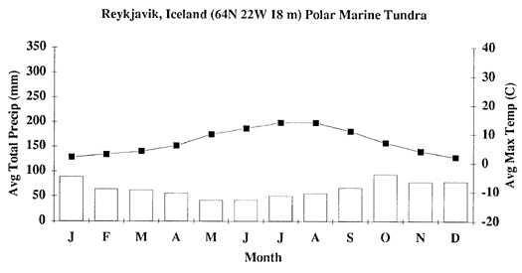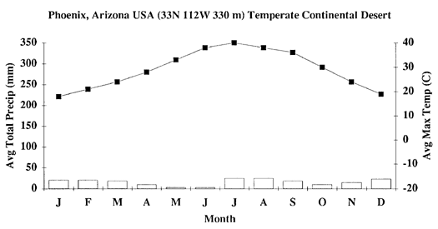

Possible Arizona Biome: _________________________ Possible Iceland Biome: _________________________

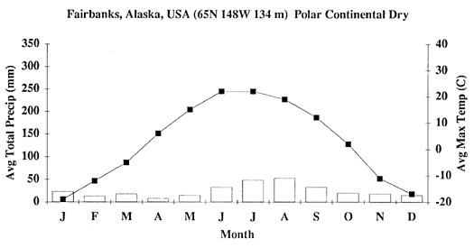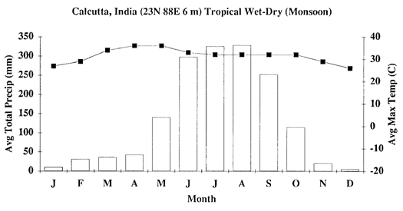

Possible India Biome: _________________________ Possible Alaska Biome: _________________________