DNA Replication Practice
Directions: Below are the 3 steps in DNA replication. Follow the directions for each step and then answer the questions below.
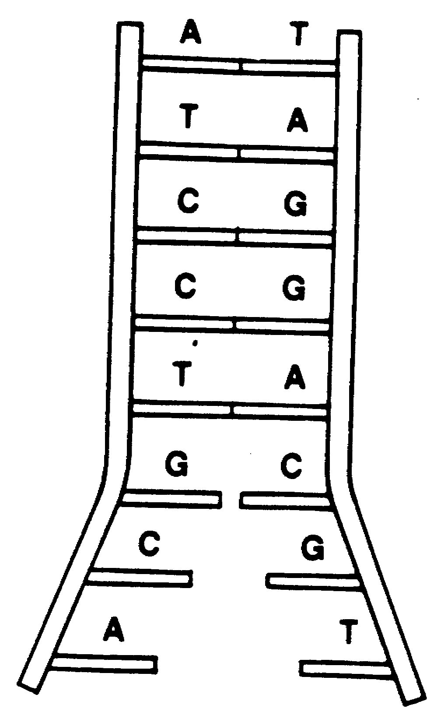
1. -Color the DNA molecule red.

-What does the diagram to the right show happening
to the DNA molecule? (Explain the first step in DNA replication).

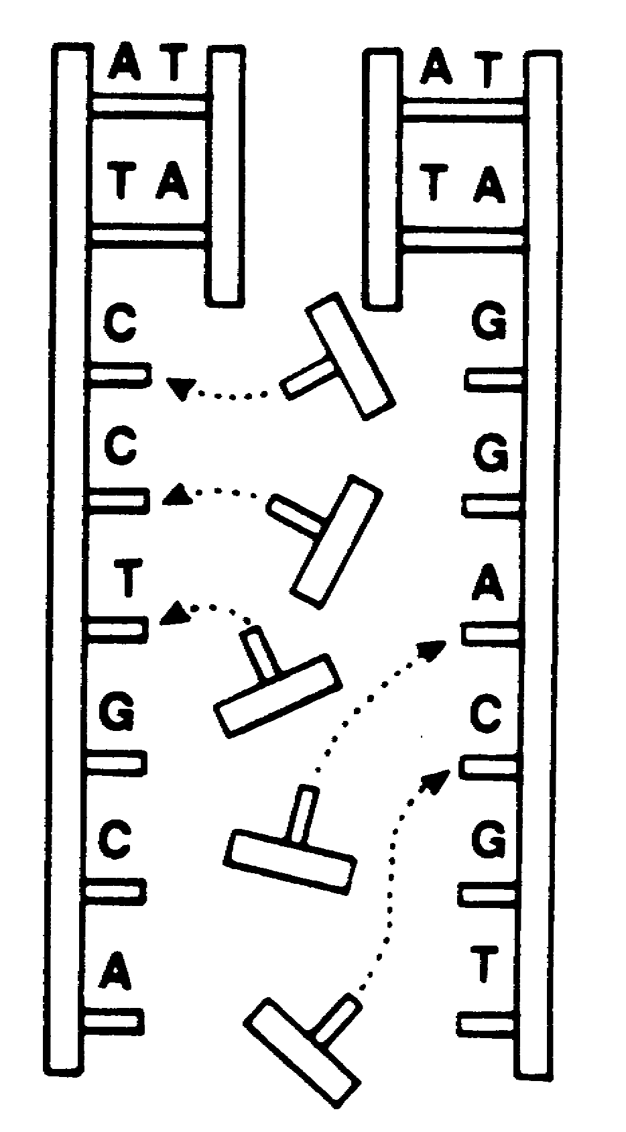
2. -Color the new DNA nucleotides in the diagram to
the right blue. Color the original DNA strands red.

-What happens to the DNA molecule during the second
step of DNA replication?

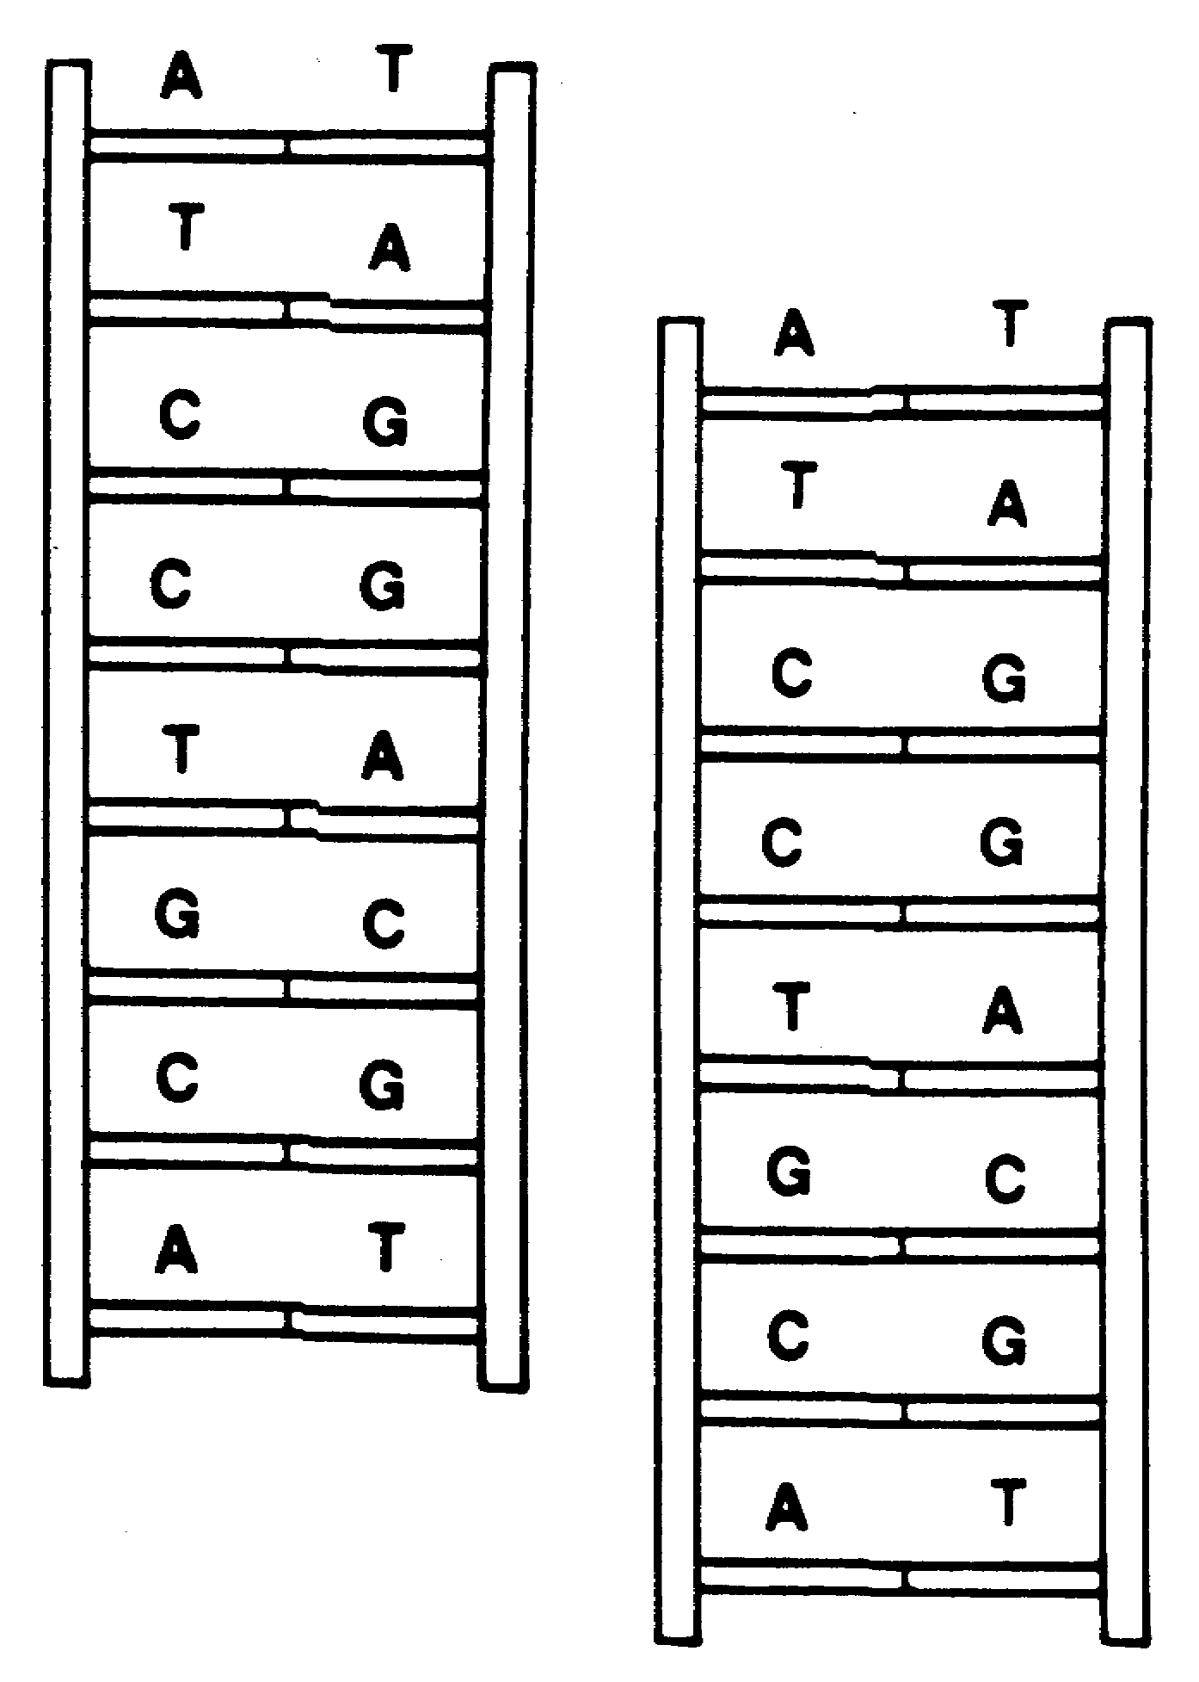
3. -Color the new DNA strands blue and color the other DNA
strands red.

-What happens during the third step of DNA replication?

-What happens during the fourth step of DNA replication?

-Explain why the fourth step is necessary?

-Which color, red or blue, represents the original template? ____________

-Explain the term semi-conservative and how it relates to what you just colored in this activity.

- What does it mean that the two strands of DNA are complementary?

- What is DNA replication?

6. Using your notes and this assignment place the steps of DNA replication in the correct order.
____ a. An enzyme moves along the exposed strands and adds complementary nucleotides to each nucleotide in each existing strand.
____ b. The DNA double helix breaks or unzips down the middle between the base pairs.
____ c. A complementary strand is created for each of the two strands of the original
double helix.
____ d. DNA polymerase “proofreads” the new strand to check for errors. Two new identical DNA molecules have been produced.

- (True or False) The process of DNA replication results in a copy of the original DNA molecule.
- (True or False) Sugars and phosphates break off from the DNA nucleotide to provide energy for DNA replication.
- (True or False) DNA does not have to break apart to be copied.
- (True or False) After DNA replication is complete, there are two new DNA molecules; one molecule has both of the original strands and one molecule has two new strands of DNA.

- Where does DNA replication happen? ______________________________________

- When does DNA replication happen? _______________________________________

- Explain why it is necessary for DNA to replicate BEFORE cellular division.

- Below are DNA strands. Make the complementary DNA strand:

Original Strand: A T G C A A A T T G C T C A C C G G G G A T C A G C A C C G G
Complementary Strand:

Original Strand: A G G G G A T C A G C A C C G G A T T T C A T G A G C C C T A
Complementary Strand:

- What do you think would happen if there was no enzyme to “proofread” this process?

Let’s See What Happens: Mutations (we will come back to this later)
      - POINT Mutation- one base is substituted for another
Example:
Original: GGT ATC GGA TTA
Replicated: GGC ATC GGA TTA

      - FRAME SHIFT Mutation- one base is added or deleted and it shifts sequence
Example:
Original: GGT ATC GGA TTA
Replicated: GGA TCG GAT TA

- What type of mutation has the greater effect on the DNA? Why?

