Graph 1:  Draw the following graph on your paper.  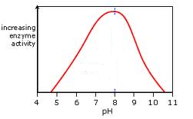  - Put a star () on your graph where the enzyme is working optimally.  - Circle on your graph where the enzyme is denatured and write “D”. | 1. Which kind of organic molecule are enzymes examples of?
 | 2. What is the job of an enzyme?
 | 3. What does it mean when an enzyme has denatured? What are the two ways to denature enzymes?
Graph 2:  Draw the following graph on your paper.  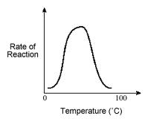  - Put a star () on your graph where the enzyme is working optimally.  - Circle on your graph where the enzyme is denatured and write “D”. | 1. What does the word optimal mean?
 | 2. What does it mean that enzymes are specific?
 | 3. What three letters will you always find at the end of the name of an enzyme? And what about carbohydrates?
Graph 3:  Draw the following graph on your paper.  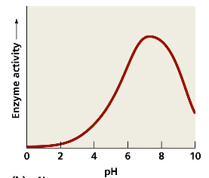  - Put a star () on your graph where the enzyme is working optimally.  - Circle on your graph where the enzyme is denatured and write “D”. | 1. What sugar does the enzyme sucrase break down?
 | 2. Draw the pH scale. Label acids, bases and neutral.
3. At what pH is this enzyme denatured?

At what pH is this enzyme working optimally?

