**Bacteria**

* 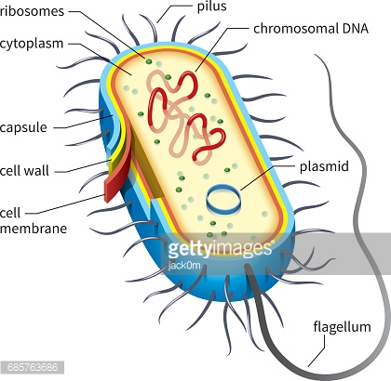**PROKARYOTIC** (NO membrane bound organelles)
* **Cell walls**
* **CHROMOSOMAL DNA (NUCLEOID)**
* **CIRCULAR DNA (PLASMIDS)**
* **UNICELLULAR**
* **Autotrophic** or **HETEROTROPHIC**
* **ASEXUAL** reproduction (binary fission)
* **ANTIBIOTICS:** used to kill bacteria
* There are two kingdoms

1. **Archaebacteria**

* + Archae = ancient = oldest life forms
  + Live in the **HARSHEST** environments
  + hot springs, deep ocean volcanic vents, swamps, sewage treatment plants
  + Ex: Methanogens, halophiles (salt-lovers), Acidophiles (acid lovers), Thermophiles **(heat**-lovers), Psychrophiles (cold-lovers)
  + Very few species

2. **Eubacteria**

* Live in **NORMAL** environments
* Ex: *E. Coli, S. Aureus, Cyanobacteria* (blue - green algae)
* Some **PATHOGENIC** and evolving **ANTIBIOTIC** **RESISTANCE**: TB (*Mycobacterium tuberculosum*), MRSA (methycilin-resistant *Staphylococcus areas*), Strep (*Streptococcus*)
* Some **BENEFICIAL**: **DECOMPOSERS** that break down organic matter and recycle nutrients in ecosystems, gut bacteria help digest food, useful in genetic engineering

**Protists**

* **EUKARYOTIC**

**Euglena**

* 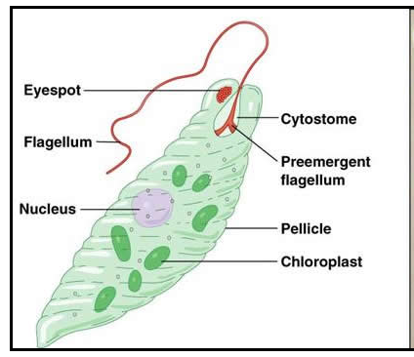Mostly **UNICELLULAR** (Amoebas & Paramecium)
* Some **MULTICELLULAR** (Algae)
* **Cell Walls**
* **Autotrophic** or **HETEROTROPHIC**
* **ASEXUAL** reproduction (binary fission)
* Some can reproduce **SEXUALLY**
* Three main groups:

1. Algae (**PLANT-LIKE**)
2. Protozoa (**ANIMAL-LIKE**)
3. Slime Molds (**FUNGUS-LIKE**)

* Some protists are **PATHOGENIC** (disease-causing)
  + **MALARIA** is caused by parasitic protists called plasmodia
  + Mosquitos (**VECTORS**) carry/transmit plasmodia
  + 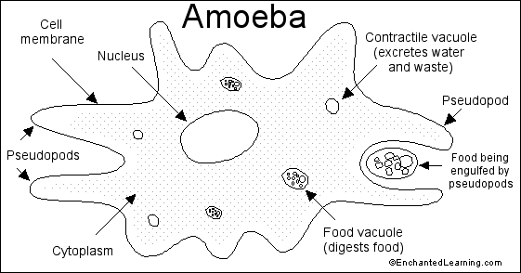Symptoms = headache, shaking, chills, fever
  + Some forms can lead to comas or death
* **Algae:**
  + Aquatic **PRODUCERS**
  + Produce most of Earth’s **OXYGEN**
  + Unicellular or multicellular (seaweed)
* **Protozoa**

**Paramecium**

* + 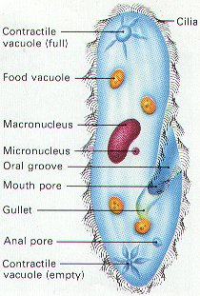Unicellular and aquatic
  + Animal-like
  + **ADAPTATIONS** to accomplish life functions:

1. **FLAGELLUM** = whip-like tail
2. **CILIA** = tiny hair-like projections
3. **PSEUDOPODS** = extensions of the cell membrane – **FOR MOVEMENT & EATING**
4. **CONTRACTILE VACUOLE** = for **WATER BALANCE**; pumps water outside the cell
5. **EYESPOT** = allows for detection & responses to light

**Fungi**

* 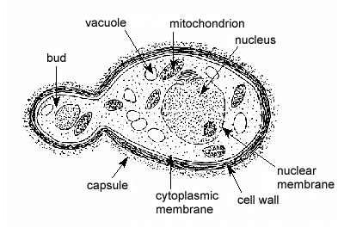**Eukaryotic**
* **Cell walls** made of **chitin**
* Mostly **MULTICELLULAR**
* **YEASTS ARE UNICELLULAR**
* **HETEROTROPHIC** – obtain food through extracellular digestion (secrete enzymes and absorb nutrients across cell wall)
* 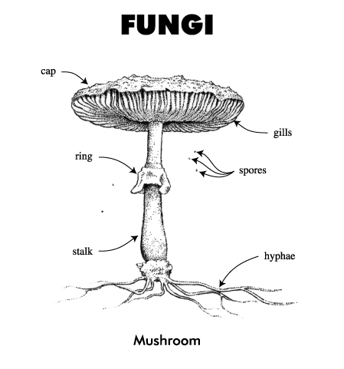**ASEXUAL** Reproduction
  + (**BUDDING** in yeasts, uses mitosis)
* **SEXUAL Reproduction** 
  + (**SPORE** **FORMATION** in mushrooms, uses meiosis)
* Some are **PATHOGENIC** (candida/yeast, athletes foot, mold)
* Act as **DECOMPOSERS** in ecosystems to recycle nutrients
* 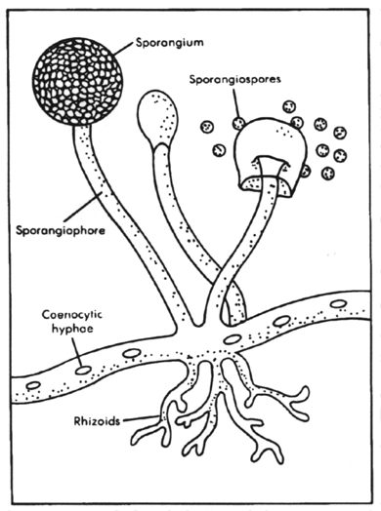Ex: fungi, molds, mushrooms, yeasts, mildews

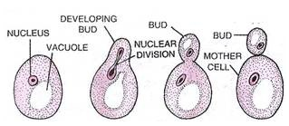

Asexual BUDDING

Sexual SPORULATION

**Plants**

* **Eukaryotic**
* **Cell walls** made with **CELLULOSE**
* **Multicellular**
* **Autotrophic** – Photosynthetic
* Mostly **SEXUAL** reproduction (pollen and eggs)
* Some **ASEXUAL** reproduction (**VEGETATIVE PROPAGATION**)
* Can be non-vascular (**NO TRANSPORT SYSTEM**) or vascular (**TRANSPORT SYSTEM**)
* **Non-Vascular Plants:**
* Lack **VASCULAR** tissue
* 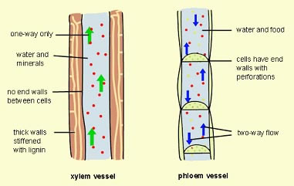transport **WATER** and nutrients from cell to cell by **OSMOSIS** and **DIFFUSION** –
* Examples: mosses/bryophytes, liverworts, hornworts
* Have sperm and egg on separate structures
* Must grow near water for reproductive life cycle
* **Vascular Plants**
* **XYLEM** – transports water
* **PHLOEM** – transports nutrients (sugar)
* most plants (ferns, gymnosperms, angiosperms)
* Special openings in surface = **STOMATA** - formed by two **GUARD CELLS**
  + **REGULATE** gas exchange (CO2 in and O2 out) and water loss (transpiration)
* Able to live on land and occupy many habitats

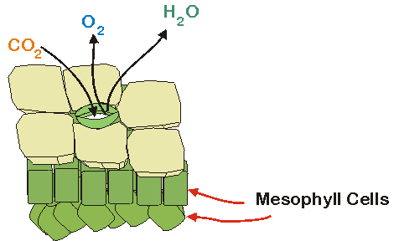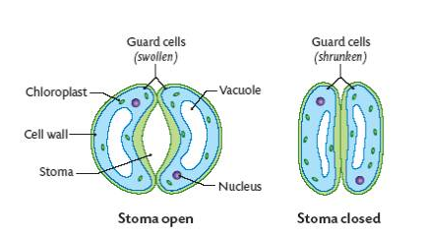

* **Gymnosperms (“Jim” likes CONES)**
* **VASCULAR** plant – have **XYLEM** and **PHLOEM**
* Gymnosperm means “**NAKED** seed”
* Their seeds are **NOT** protected by any outer covering
* Seeds are produced on the outside of **CONES**
* Gymnosperms include conifers (pine trees and spruce trees)
* Most pollination is caused by the **WIND**
* Gymnosperms produce **POLLEN** in male cones which fertilizes **EGG** in female cones
* **Angiosperms (Angie loves FLOWERS)**
* **VASCULAR** plant – have **XYLEM** and **PHLOEM**
* Angiosperm means “**COVERED** seed”
* 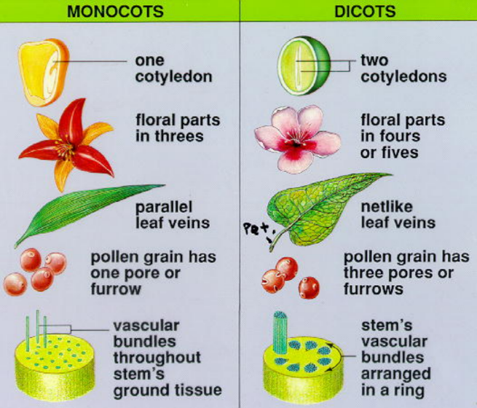Their seeds are protected by ovaries - which surround the seed and mature into **FRUIT**
* Angiosperms also produce **FLOWERS** - which attract pollinators
* Pollination is caused by insects or birds that transfer **POLLEN** from one flower to another
* Most plants are **ANGIOSPERMS**
* Angiosperms can be **MONOCOTS** (one cotyledon) or **DICOTS** (two cotyledons)

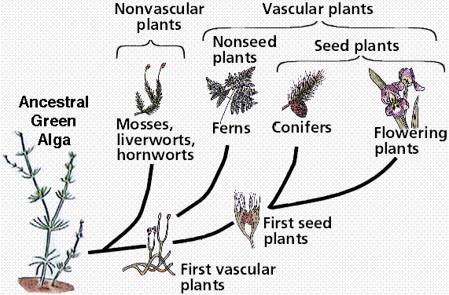

* 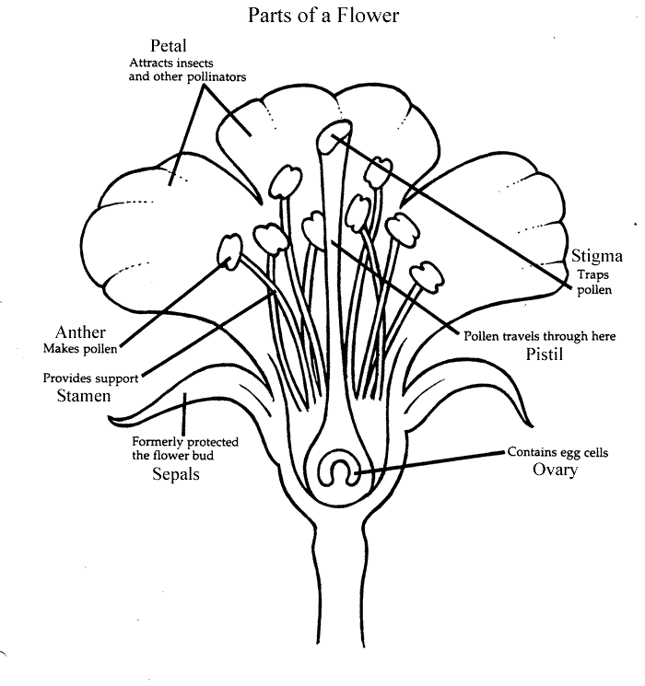**SEXUAL Reproduction**:
  + **STAMEN** = male reproductive structure
    - anther (produces pollen containing sperm)
    - filament
  + **PISTIL**/carpel = female reproductive structure
    - Stigma (sticky and collects pollen)
    - Style
    - Ovary (holds ovules containing eggs)
  + **POLLINATION** = pollen is transferred to the stigma
  + **FERTILIZATION** = pollen reaches and fuses with egg
  + The fertilized egg becomes a **SEED**
  + As the seed forms, the ovary swells and ripens to form **FRUIT** (aids in dispersal of seeds)

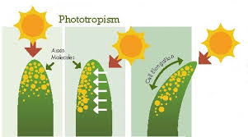

* **Tropisms:**
* Plant growth responses to external stimuli
* Examples:

1. **PHOTOTROPISM** = response to light
2. 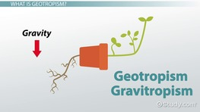**GRAVITROPISM/GEOTROPISM** = response to gravity (roots grow toward gravity; stems grow against it)
3. **THIGMOTROPISM** = response to contact/touch (vine)

* **Regulation**
* Plants produce **HORMONES** which regulate their growth and development and may control responses to stimuli
* Examples:
  + **AUXINS** = allow for elongation of the cell; allows the plant to bend
  + **CYTOKINENS** = promote rapid cell division (prevalent in roots/stem)
  + **ETHYLENE** = gas that promotes fruit ripening

**Animals**

* **EUKARYOTIC**
* **Multicellular**
* **HeterotrophIC**
* **NO cell WALL or CHLOROPLAST!!!**

**Invertebrates**

(do **NOT** have a backbone)

* 95% of all animals
* Ex: sponges, jellyfish, worms, insects, crustaceans, spiders, and starfish

**Vertebrates**

(have a **BACKBONE**)

* + Ex: fish, amphibians, reptiles, birds, mammals
* **Symmetry** = whether one half of the animal matches the other half
  + - **ASYMMETRY** - does not match (sponge)
    - **RADIAL** - matches **IN A CIRCLE** (jellyfish)
    - **BILATERAL** - matches **IN HALVES**

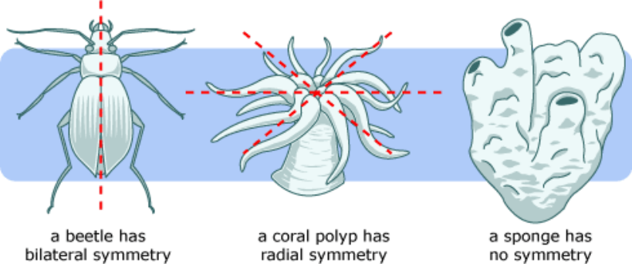

* **Segmentation** – division of some animals into **REPEATED** parts (ex: earthworm)
* **Cephalization** – concentration of sense organs in a **HEAD** region

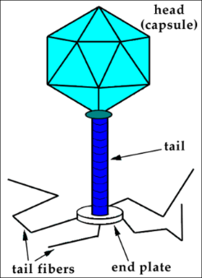**Viruses**

* Do not belong to a **KINGDOM**
* 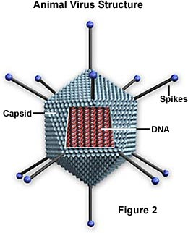**NOT LIVING** due to a lack of **CELLULAR** **STRUCTURE**
* Can only reproduce in a **HOST** cell
* Composed of a capsid (**PROTEIN** coat) and nucleic acid (**DNA** or **RNA**)
* Mutate and EVOLVE very quickly
* **PATHOGENIC** - cause disease
* Examples: Chicken Pox, Influenza (flu), HIV, Ebola
* Reproduction: Lytic or Lysogenic Cycle

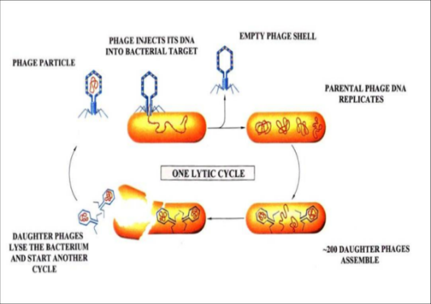

**Lytic Cycle:** Virus invades the cell and takes over to produce hundreds of copies. The cell eventually bursts (lyses) and dies.

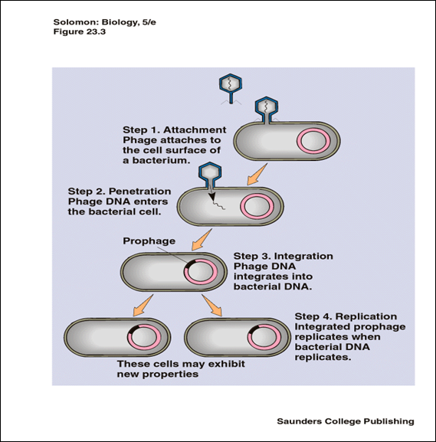**Lysogenic Cycle:** Virus invades and hides in the DNA of a cell for a dormant period while it remains inactive. Under stress or another signal, the virus will begin the lytic cycle.

**VACCINES**: killed/weakened/dead virus or viral proteins injected to cause an immune response and protection from future viral infections; provide **ACTIVE IMMUNITY** = body will begin producing protective **ANTIBODIES** to the virus.

**STERNGRR in Animal Kingdom**

**SYNTHESIS** - how organisms build/make necessary molecules

* + - Protein synthesis – ribosomes are used to make proteins from amino acids based on DNA code [**DNA 🡪 mRNA 🡪 protein**]
    - Lipid synthesis – the ER produces lipids like phospholipids for cell membranes

**TRANSPORT** - how organisms get what they need to cells; move materials

* + - Red blood cells carry nutrients and oxygen to cells and carry waste products away from those cells
    - **HEMOGLOBIN** = oxygen transport protein on RBCs

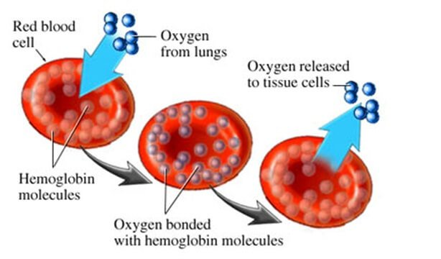

**EXCRETION** - how organisms get rid of their wastes

* + - 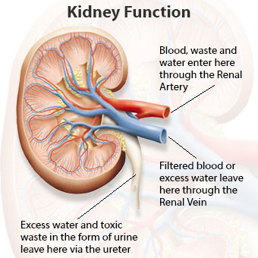Invertebrates 🡪 have specialized structures to filter waste from blood; **NEPHRIDIA** in annelids and **MALPIGHIAN TUBULES** in insects
    - Vertebrates 🡪 use **KIDNEYS** that are made up of nephrons to filter wastes

**RESPIRATION** – (Not *Cellular* Respiration)

****Gas Exchange - how organisms get oxygen from the environment and release carbon dioxide back to the environment

* + *Worms* 🡪 oxygen can diffuse through moist **SKIN** and enter bloodstream; large **SURFACE AREA** to body volume helps increase **DIFFUSION**
  + *Aquatic invertebrates and vertebrates* 🡪 use **GILLS** to allow diffusion of oxygen from water into bloodstream
  + 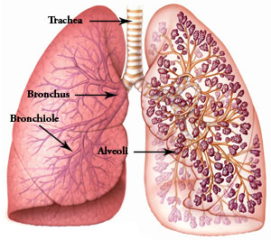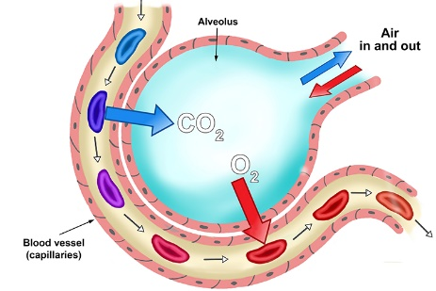*Terrestrial invertebrates* 🡪 rely on **LUNGS** with **ALVEOLI** (small air sacs that allow for fast diffusion of oxygen into blood and carbon dioxide out of blood)

**NUTRITION** - how organisms obtain, break down, and absorb food

* + Insects have chewing mouthparts called **MANDIBLES**
  + Vertebrates have **TEETH**
  + Digestive tracts include an esophagus, stomach, and intestines
  + 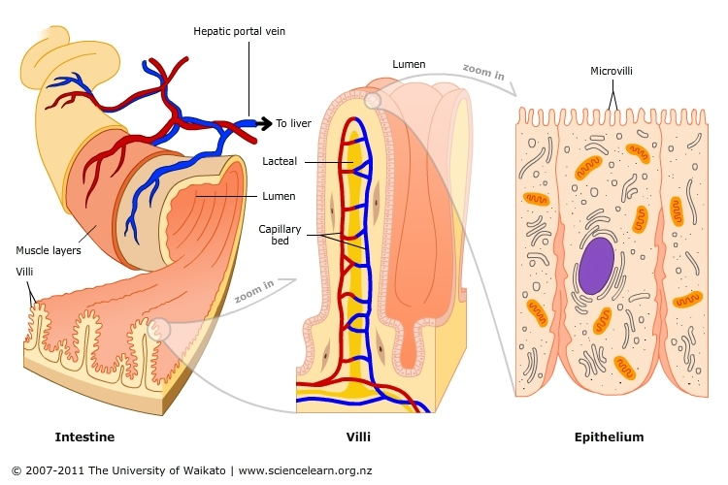**VILLI & MICROVILLI** - fingerlike projections that line the intestines and increase **SURFACE AREA** to maximize nutrient absorption
  + Secretion of **ENZYMES** to break down polymers into usable monomers

**REPRODUCTION** - sexual verses asexual types of fertilization

* + 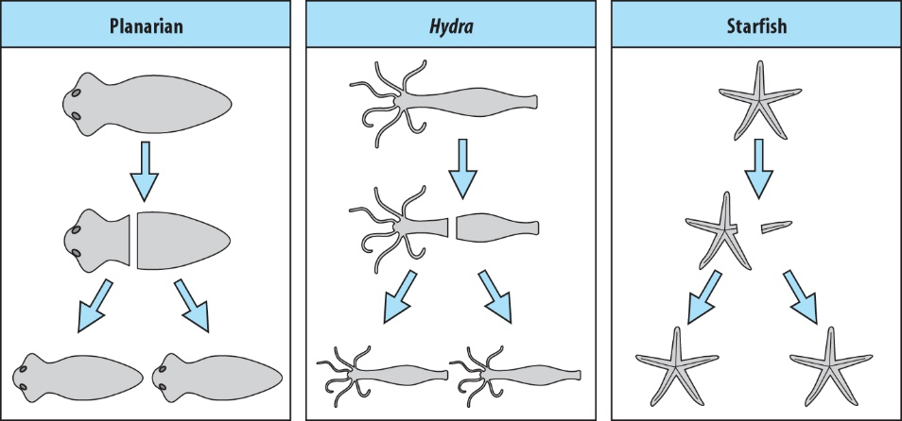Asexual Methods:
    - **FRAGMENTATION**
    - **REGENERATION**
    - Budding
    - Cells divide using mitosis

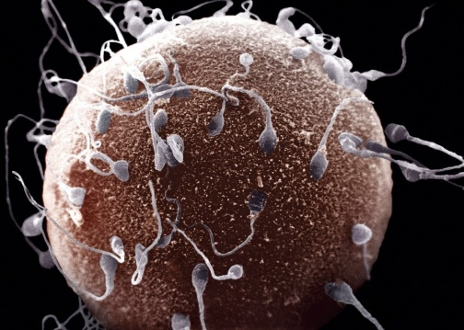

* + Sexual Methods
    - Hermaphroditic
    - Egg and Sperm
    - Gametes produced by meiosis

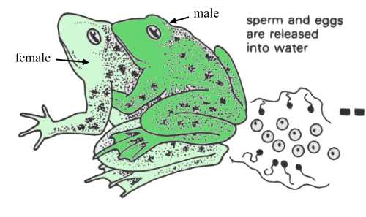

* + Fertilization Methods:
    - **EXTERNAL** fertilization
      * females lay eggs and males fertilize **OUTSIDE** the body
      * fertilization usually in water

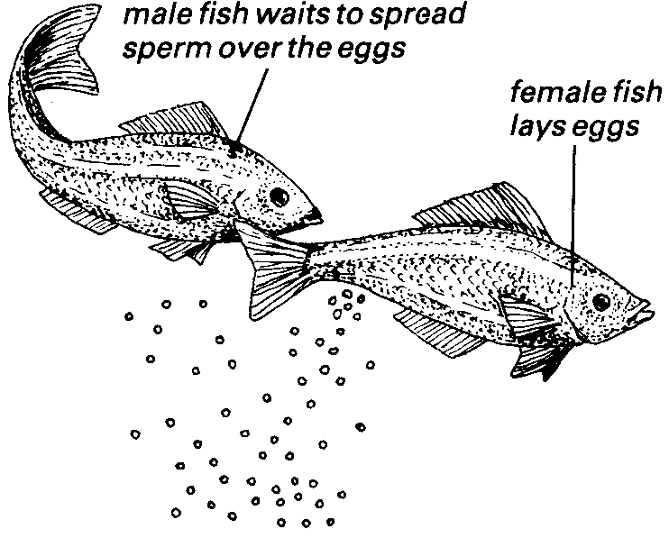

* + - **INTERNAL** fertilization
      * Male deposits sperm inside the female
      * Land animals

**GROWTH/DEVELOPMENT**-

* *Growth* = increasing in size or number of cells
* *Development* = maturation
* Insects and amphibians 🡪 undergo **METAMORPHOSIS**
  + **INCOMPLETE** metamorphosis = egg 🡪 nymph 🡪 adult
  + **COMPLETE** metamorphosis = egg 🡪 larva 🡪 pupa 🡪 adult

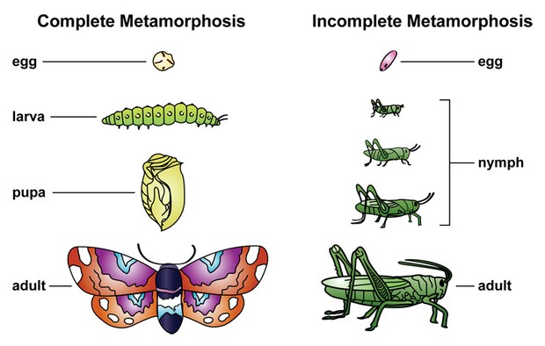

* Reptiles, birds, and mammals 🡪 called monotremes lay **AMNIOTIC** egg (protective environment for the embryo to develop on land without drying out)
* Marsupials 🡪 develop in mother’s pouch
* Most mammals develop in uterus of the mother; **PLACENTA** connects the embryo/fetus to the mother’s circulatory system

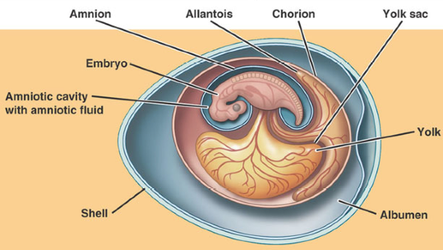

**REGULATION** - control the body’s responses by responding to stimuli and maintains homeostasis

* + - **NEURONS** - basic unit of the NERVOUS SYSTEM (found in animals)
      * Form to Function
      * Long dendrites and axon help to transmit electrical signals and communicate with other neurons and muscles

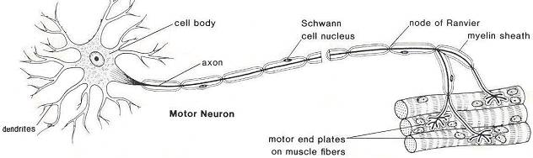

* + - **HORMONES** - part of the ENDOCRINE SYSTEM
      * Proteins that travel through the bloodstream to communicate with target cells
      * found in plants and animals

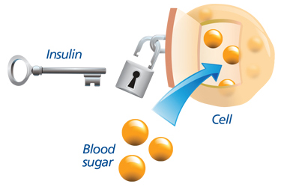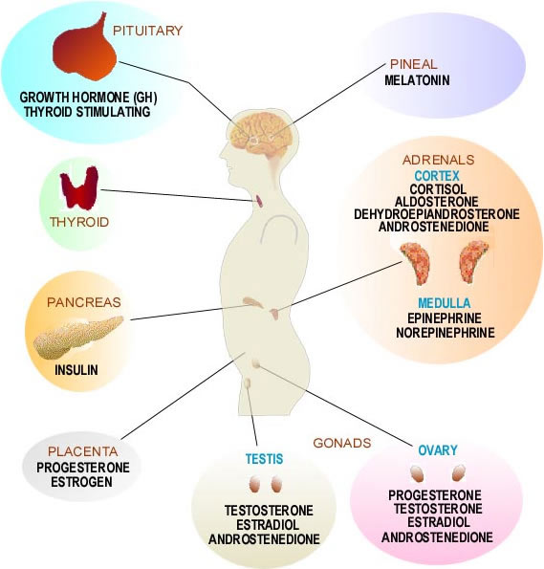

INSULIN is an important hormone secreted by the pancreas to regulate blood glucose/sugar.

* Product of genetic engineering