Name: _____________________ Date: _______________

Biology Mid-Term Study Guide

This study guide packet is due the day of the mid-term exam. If you complete it, it will replace your lowest test grade with a 100%

The following review covers the chapters in the first nine weeks. To properly prepare for the exam you should:
1. Complete and Review this packet
2. Organize and review your notes
3. Review old tests & study packets
Good Luck!

Remember: Your exam accounts for 20% of your first/third quarter grade!

Chemistry of Life

- What is the pH scale? On the scale below show where acids, bases and neutral are located.

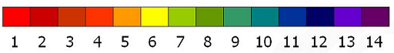

- What is a biological catalyst?

- In the human body what structure functions as a biological catalyst?

Organic Chemistry
- What is matter?

- What is an element?

- What is a molecule?

- What makes a molecule organic? Give an example of an organic molecule.

- What is a monomer?

- What is a polymer?
Fill out the following table about organic compounds:
Organic Compound: | Function | Building Block | Examples | Draw the structure
Protein

Carbohydrate

Lipid

Nucleic Acid

- Identify the following as a nucleic acid, protein, lipid, or carbohydrate:

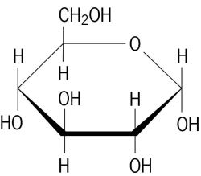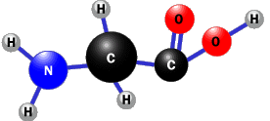
A
B

C
D
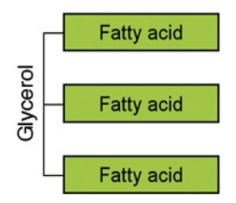
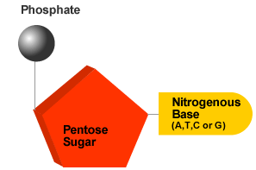

Enzymes
- What is an enzyme?

- What are the subunits of enzymes? How do you know this?
- Label the picture of the lock and key model of enzyme activity below with the following labels: enzyme, substrate, enzyme-substrate complex, active site, products

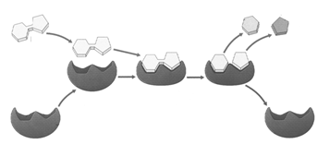

- For each of the following statements, label as true or false
_____ a. Enzymes are types of proteins
_____ b. Enzymes slow down the rate of chemical reactions
_____ c. Each enzyme is specific, it only works on one type of substance
_____ d. Enzymes become denatured (melt) at high temperatures
_____ e. Enzymes can be denatured by a change in pH
_____ f. Enzymes can not be reused.
g. Enzymes speed up reactions by lowering activation energy
_____ h. Proteins are made of building blocks called amino acids
_____ i. Proteins are made in the mitochondria of cells

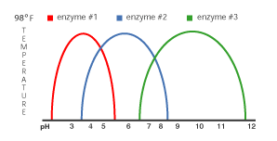

- Use the graphs above to answer the questions:
- Does enzyme number 1 function at a pH of 5.5? ____ __
- What is the best pH for enzyme number two? ______ _
- Which enzyme has the broadest ph range? __________ _

Cell Structure and Function

- What are three differences between prokaryotic cells and eukaryotic cells?

- What are three differences between a plant cell and an animal cell?

- Give an example of a prokaryotic cell

- Give an example of a eukaryotic cell

- Matching: Next to each organelle, write the letter of its function

______ mitochondria a. where proteins are made

______ cell membrane b. site of photosynthesis in plants, contain chlorophyll

______ cell wall
- provides support and protection for plant cell
______nucleus
- storage area for the cells
______ vacuole
- powerhouse of the cell, makes energy
______chloroplasts
f. control center of the cell, contains the genetic ______ribosome ribosome information

- is selectively permeable, controls what goes in and out of the cell

- Label the diagrams of the cells below:

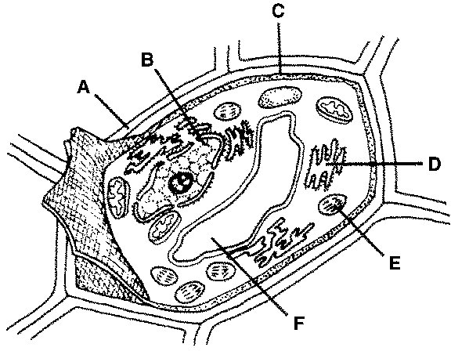
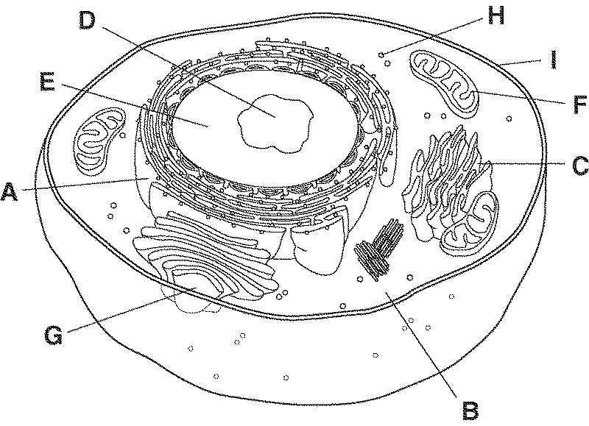

Animal Cell:
A.
B.
C.
D.
E.
F.
G.
H.
I.

Plant Cell:
A.
B.
C.
D.
E.

- What does selectively permeable mean?

- Label the parts of the membrane:

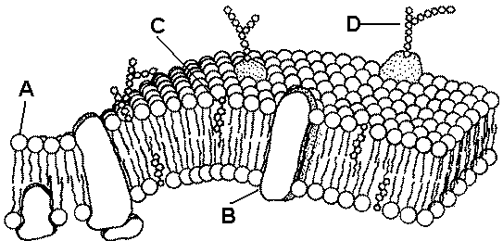

- What is the function of the cell membrane?

- What is diffusion?

- What is dynamic equilibrium?

- What is osmosis?

- What is active transport?

- What type of organic molecule is needed for active transport?

- What is the difference between passive and active transport?

Ecology
Define the vocabulary below and give an example where stated.
- biotic factor -
examples -
- abiotic factor -
examples -
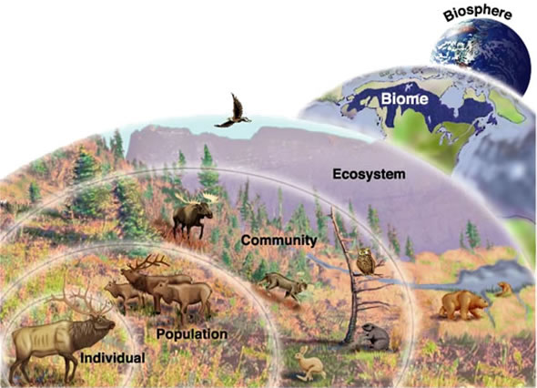

- producer -

also called
- consumer -

also called
- Herbivore -
- Carnivore -
- Omnivore -
- Decomposer -
Examples of main decomposers -
- Food chain/web -
Only of energy travels from link to link, the rest is lost as !!
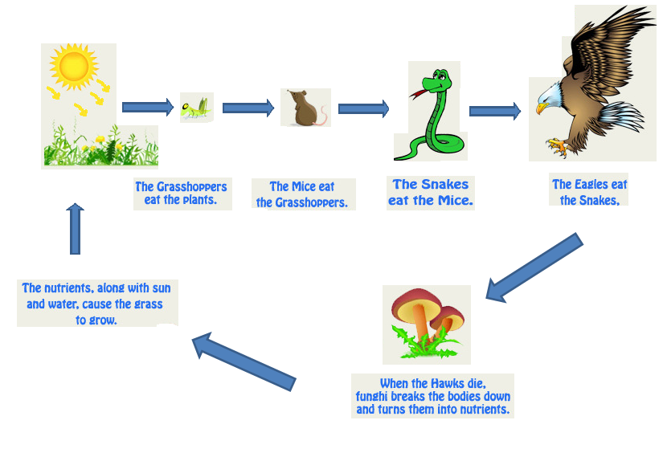
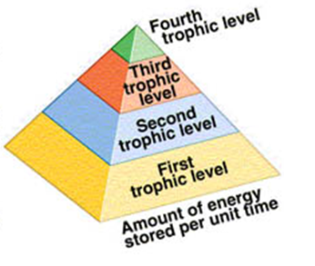

Symbiotic relationships
Fill out the chart below defining each type of symbiotic relationship.
Mutualism | Commensalism
Parasitism | Predator/prey

Population Growth
Exponential growth -
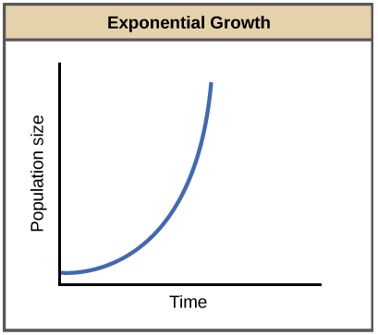
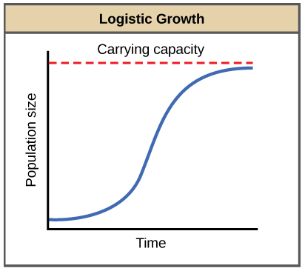
Logistic growth -

Predator/prey curves -
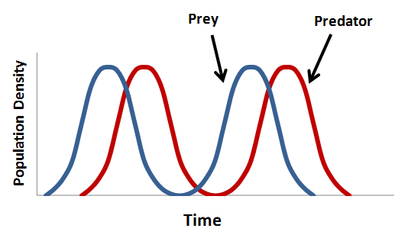

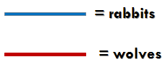

Limiting factors
Density-dependent -
~examples -
Density-independent -
~examples -

