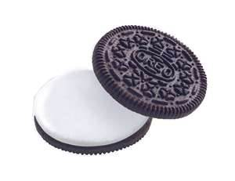
Oreo Mitosis
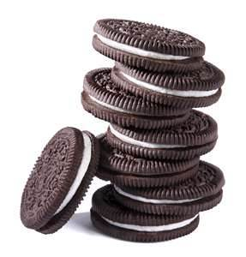
Student Worksheet

Materials Needed:
6 Oreo Cookies (per group)
2 Tablespoons/about 36 assorted color rod-shaped candy sprinkles
6 Toothpicks (2 per group member)
Paper towels

Directions:
1) Using your Biology textbook pages 246-247 or other classroom resources, find an image of the cell cycle that includes: interphase, mitosis (prophase, metaphase, anaphase and telophase) and cytokinesis.
2) Using the image you found, you will create a model for each stage of the cell cycle listed above.
3) If your group has two members, each member will model three stages. If your group has three members, each member will model two stages of the cell cycle.
4) Carefully remove the top cookie from all six cookies by twisting the top cookie in a circular motion while holding the bottom cookie with your other hand. The bottom cookie with the cream filling attached will be used for your models (Note: You may eat the top cookie, or lay it aside.).
5) The cream filling represents the cytoplasm of the cell. You must create the structures inside the cell that play a role in the cell cycle using candy sprinkles.
6) The toothpicks may be used to remove or divide the cytoplasm or to move around the sprinkles.
7) Once you have created a model for each stage of the cell cycle, summarize what is happening in each stage in the table below AND draw each phase in the appropriate boxes in your packets.
Stage | Summary of Important Events
Interphase
Prophase
Metaphase
Mitosis
Anaphase
Telophase
Cytokinesis

8) Once you have modeled each stage, summarized the key events, and drawn each phase in your packets, ask your teacher to review your models and summary.
9) Once your teacher confirms that your models and summary are accurate, you and your group may consume what remains of your Oreo cookie models.
10) Clean-up: Discard all materials from your lab once your teacher approves of your models and summary. Wipe off all surfaces to remove crumbs.
11) Answer the analysis questions below.

Analysis Questions:
- During which phase of mitosis do the sister chromatids split apart and move toward the poles of the cell?

- During which phase of mitosis does the nuclear membrane reappear around the newly formed sets of chromosomes?

- When are the chromosomes/DNA replicated?

- During which phase of mitosis do the chromatids line up in the middle of the cell?

- From what structures do the spindles originate?

- Which phases are part of mitosis?

- Explain what is occurring during cytokinesis.

- Define homologous chromosomes.

Bonus:
How creative are you? Can you think of a sentence to help you remember the order of events in the cell cycle?
Example: I play music at the club.

I-________ P-________ M-________ A-________T-________C-_________

The best mnemonic device (sentence) will receive an extra Oreo .

