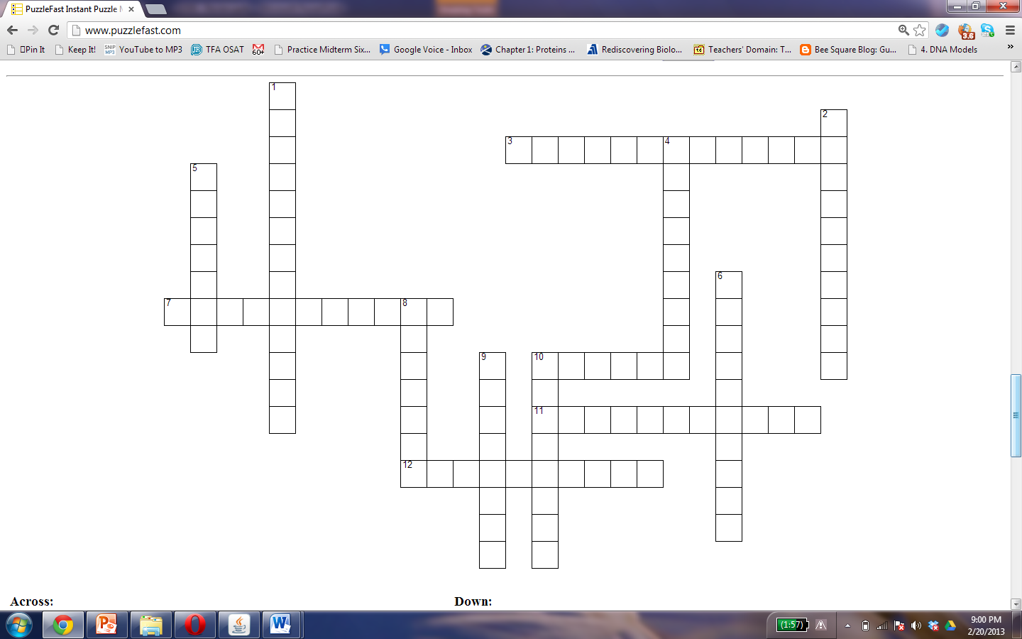

Unit 3 Crossword Puzzle

|  |  |  |  |  |  |  |  |  |  |  |  |  |  |  |  |  |  |  |  |  |  |  |  |  |  |  |  |  |  |  |  |
| --- | --- | --- | --- | --- | --- | --- | --- | --- | --- | --- | --- | --- | --- | --- | --- | --- | --- | --- | --- | --- | --- | --- | --- | --- | --- | --- | --- | --- | --- | --- | --- |
| |  | | --- | | **Across:** | | |  |  | | --- | --- | | **3.** | **describes an organism that is composed of more than one cell** | | **7.** | **describes an organism that is composed of only one cell.** | | **10.** | **something that gets dissolved in another substance** | | **11.** | **when the amount of solutes on both sides of the membrane are the same.** | | **12.** | **a byproduct of fermentation that causes muscle fatigue and soreness** | | | |  | | --- | | **Down:** | | |  |  | | --- | --- | | **1.** | **describes something that allows some things to pass through but not others.** | | **2.** | **structures within a cell made from molecules that perform a particular task** | | **4.** | **cells that contain a nucleus, membrane bound organelles, and chromosomal DNA** | | **5.** | **a chemical that travels through the blood and allows cells to communicate.** | | **6.** | **a single-celled organism lacking a nucleus, any membrane bound organelles, and has circular DNA** | | **8.** | **a byproduct of fermentation by yeast** | | **9.** | **a mixture of two or more substances where one is dissolved in the other.** | | **10.** | **a cell that has no special job; a cell that has not yet differentiated.** | | |

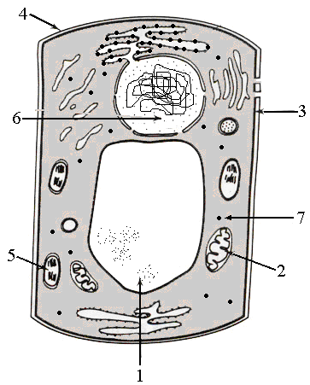

**Name: _____________________________________________**

|  |  |
| --- | --- |
| **What are the labeled organelles in the plant cell above?** | **What is the function of the organelle?** |
|  |  |
|  |  |
|  |  |
|  |  |
|  |  |
|  |  |
|  |  |