Natural Selection in Peppered Moths
U6-7
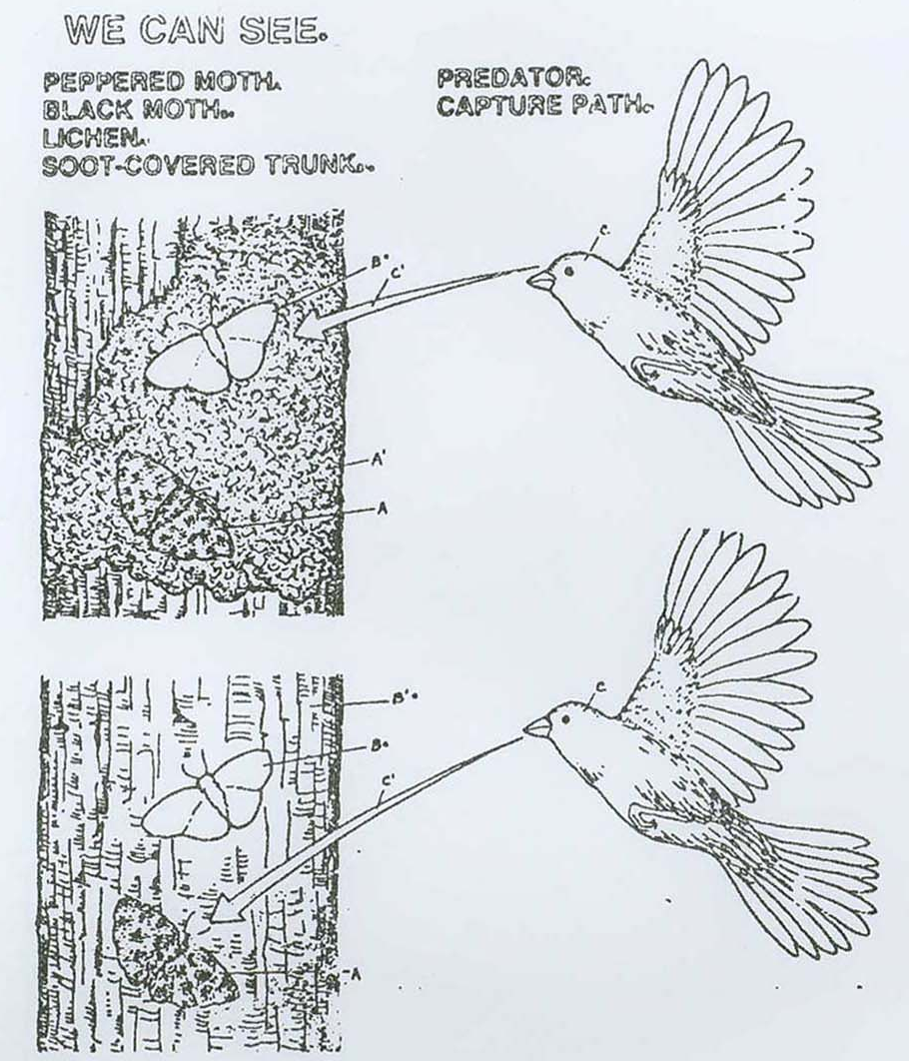
Activity Instructions:
- Place the twelve “moths” on the dark “tree bark.”

- Imagine that you are a bird that eats insects. Describe the appearance
of the moths that you would most likely capture first: __________________
_____________________________________________________________________

- Continue doing this until all but the last moth is gone.
Describe the appearance of the last moth: ___________________________
_____________________________________________________________________

- Is there any trend or sequence in the color of moths that you captured? Describe the trend: _________________________________________________
____________________________________________________________________

- Which of the moths were better “adapted” (suited to survive) to the environment of the dark tree trunk? __________________________________
_____________________________________________________________________
_____________________________________________________________________

- Now place all of the moths on the light “tree bark.”

- You are a bird. Which moths will you capture first this time? ____________
_____________________________________________________________________
_____________________________________________________________________

- Continue doing this until all but the last moth is gone.
Describe the appearance of the last moth: ___________________________
_____________________________________________________________________
_____________________________________________________________________

- What would you say would be the color characteristic of future generations of moths living on the light colored tree trunks? Why?
_____________________________________________________________________
_____________________________________________________________________

Peppered Moths Survey
U6-6
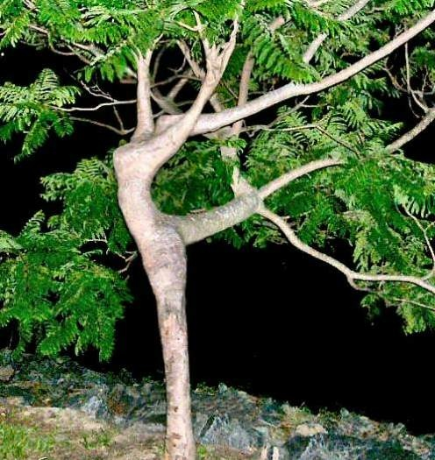
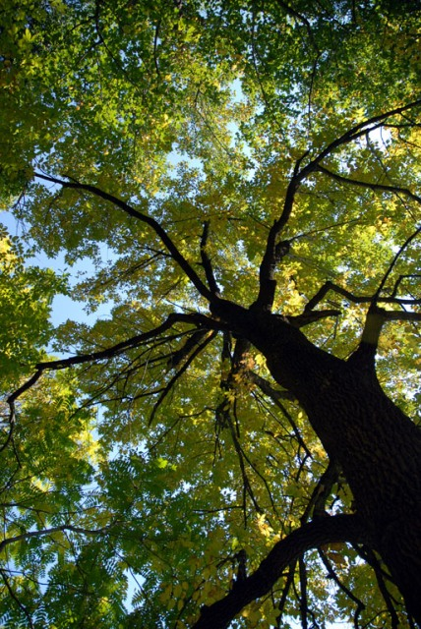
Before the industrial revolution, the trees in the forest around Manchester, England were light grayish-green. The peppered moths that lived in the area were light with dark spots. Their coloring served as protective camouflage against predators, especially birds. As the industrial revolution progressed, the trees became covered with soot, turning the trunks dark. Over a period of 45 years, a change in the peppered moths took place.

In this investigation, you will observe the effects of industrialization on the peppered moths over a period of 10 years. You will then determine the relationship between the environmental changes and the color variation of the peppered moths. You will use your research data to graph the effects of environmental adaptation.

The table contains data from a 10 year study of two varieties of the same species of peppered moth. The numbers represent the number of moths captured in each of 10 consecutive years. The traps were located in the same area each year.

Years | Number of Light Moths Captured | Number of Dark Moths Captured
2 | 550 | 100
3 | 500 | 200
4 | 400 | 210
5 | 250 | 300
6 | 225 | 350
7 | 200 | 400
8 | 150 | 500
9 | 100 | 600
10 | 50 | 650

Number of moths captured | 600
Number of moths captured | 500
Number of moths captured | 400
Number of moths captured | 300
Number of moths captured | 200
Number of moths captured | 100
Number of moths captured | Years
- Construct a line-graph showing the number of each variety of moth captured years 1 through 10.
- Use two different symbols: light and • dark

Answer the following questions:
- What do you think eats peppered moths?

- What caused the trunks of many trees to turn from light to dark in Manchester, England?

- Which variety of moths increased over the 10 year period of the study?

- How did the change in the Moth’s environment cause natural selection to take place? What type of Moth was “selected” for over a ten year period?

- What effect would cleaning the soot off of the trees have on the moths?

- “Survival of the Fittest means you have to be the strongest to survive”. Is that true in this case? Explain.

- Imagine that there was no variation in the moth population – all of them were completely white. Would natural selection and evolution be able to occur? Why or why not?

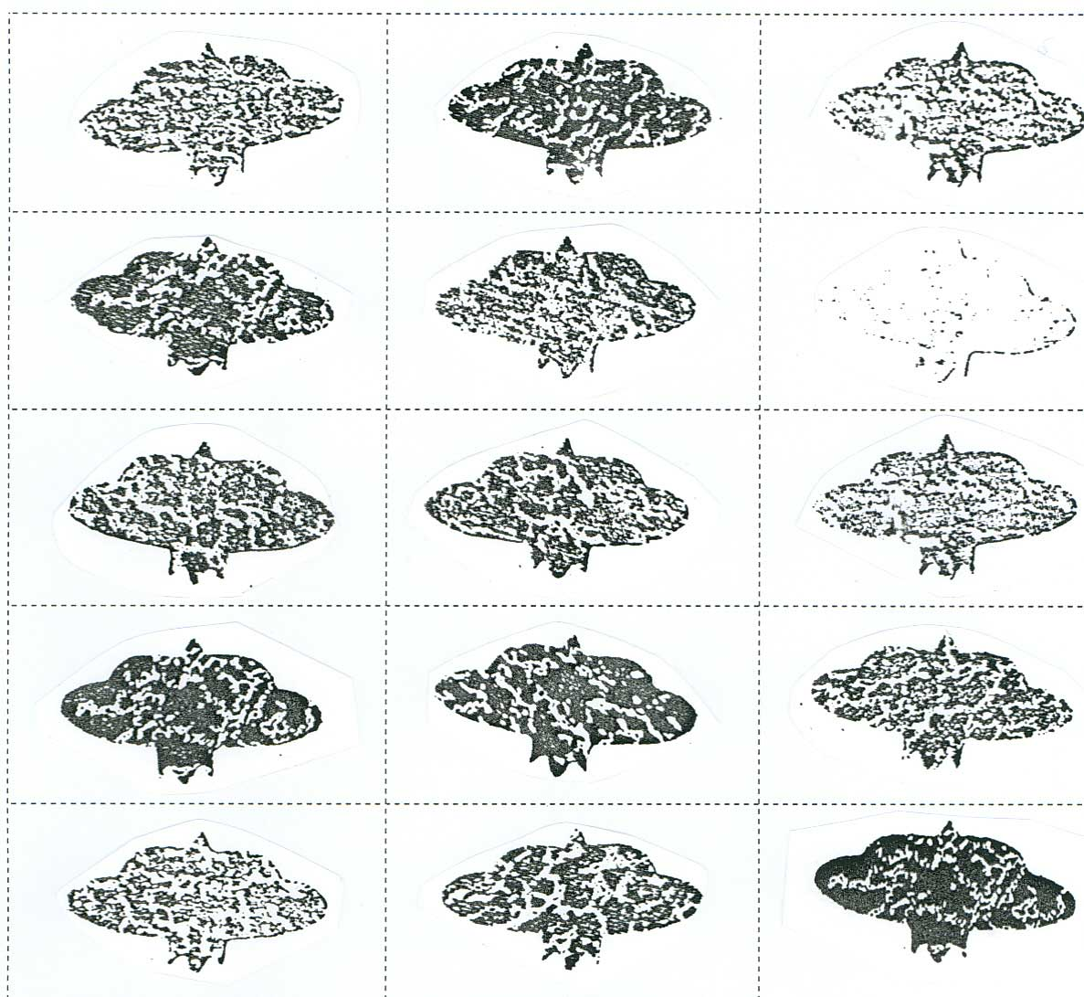
Print Out - Moths

LIGHT TREE BARK
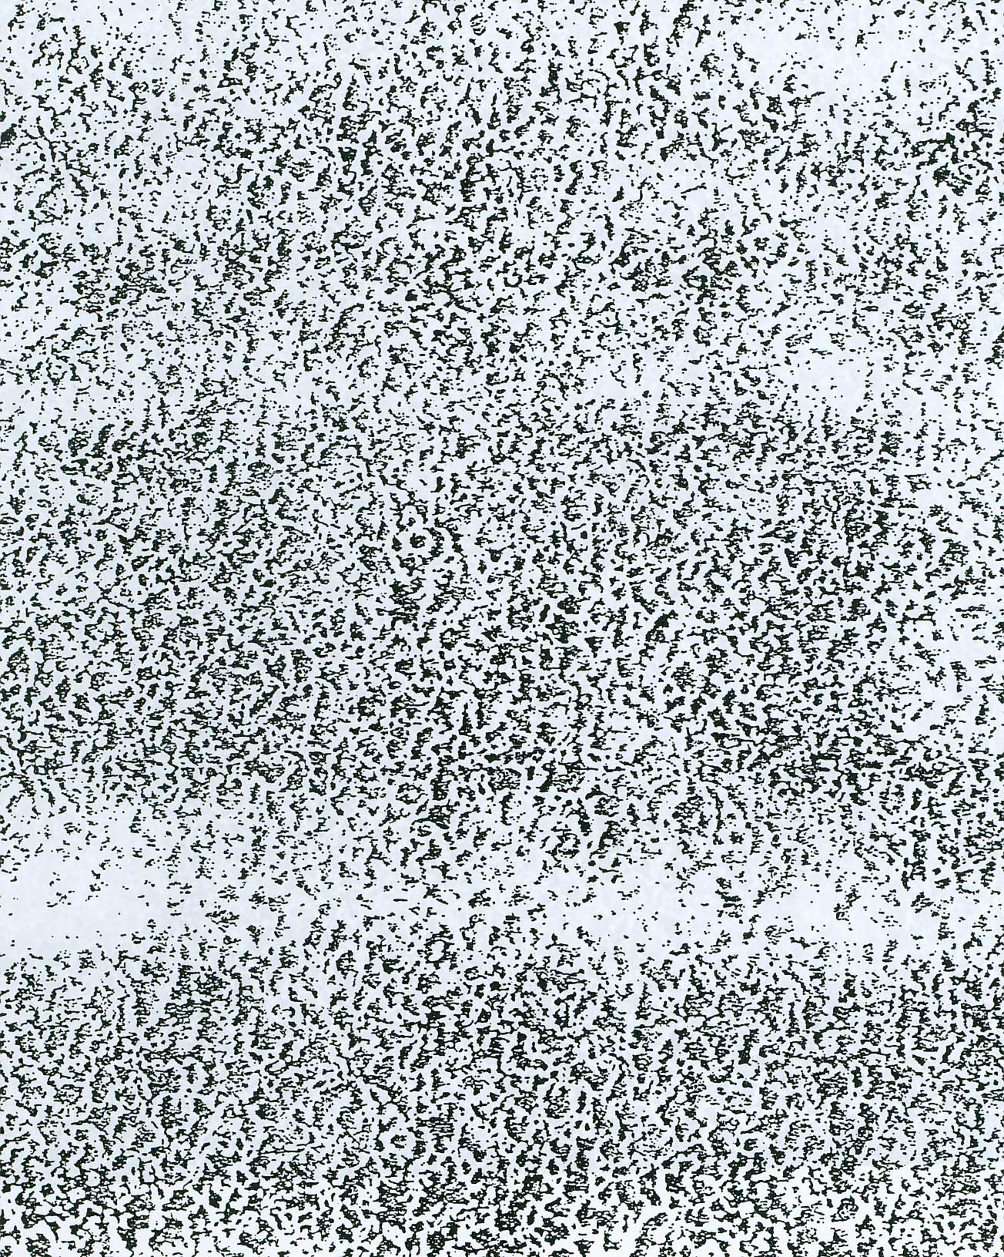
DARK TREE BARK


